A Field Guide to Community Based Adaptation
Example of Field Assignment 2: Results from facilitating a Participatory Capacity and Vulnerability Assessment Workshop
Tim Magee

Text Box 2.1
Field Assignment 2.
Activity 1. 1 1/2 hours. Seasonal calendar

This exercise is to draw a seasonal calendar in the form of a matrix on a sheet of newsprint—or several sheets taped together. On this calendar you’re trying to establish relationships between times of the year, and seasonal events that happen in the community. These could include:
- the rainy season
- the dry season
- periods of drought
- extreme weather events; flooding
- important livelihood activities
- disease
- periods of hunger
- planting and harvesting
- school
- annual festivals or ceremonies

Along the top row of the matrix write the initials for the 12 months of the year. It's helpful to create the matrix the day before the workshop. So that all workshop participants can engage in the activity you can make it very visual by drawing seasonal symbols—such as harvesting maize—so that non-readers will be included.

Along the vertical column on the left you can begin writing down events as community members come up with them. Then, adjacent to the event you can make a mark in the appropriate months that the event occurs. One helpful technique is to have a preliminary piece of paper that you can quickly write down participants’ ideas. This will give participants the freedom to speak openly and quickly. After a good number of ideas have been voiced, take a moment to organize the key events since many will be related to each other or simply phrased in a different manner. When you're satisfied with the organization of the events you can transfer them to the blank calendar.

Once the calendar has been filled in with events and dates, introduce the following questions:
- Are the hazards concentrated in one time period or season?
- Are there time periods in the year which are the most difficult for community members and their livelihood assets?

Note:
- What are the community members’ current coping strategies for dealing with these difficult periods?
- Capacity building: Which of the difficult periods they are having trouble coping with due to a lack of strategies?

Table 2.1. Course project example: seasonal calendar
Event | J | F | M | A | M | J | J | A | S | O | N | D
Dry season | X | X | X | X |  |  |  |  |  |  | X | X
Planting |  |  |  | X | X |  |  |  |  | X
Rainy season |  |  |  |  | X | X | X | X | X | X
Drought |  |  |  |  |  |  |  | X | X
Hunger |  |  |  |  |  |  | X | X | X | X
Harvest |  |  | X |  |  |  |  |  |  |  | X
Flooding |  |  |  |  | X | X |  |  |  | X
School | X | X | X | X | X | X |  | X | X | X

Text Box 2.2
Field Assignment 2.
Activity 2. 1 1/2 hours. Participatory climate hazard map
This exercise will be drawing a participatory hazard map of the community. Participatory mapping is an inclusive tool because all workshop participants can engage in the activity as it's very visual—non-readers will be included.

Consider returning to the village the day before this exercise to tour the farm fields, forests, and water sources with one of the villagers. Take a few minutes to talk to people you meet in order to gain a greater understanding of some of the challenges they are facing.

Draw the community map on a sheet of newsprint—or several sheets taped together. Begin by drawing a very simple drawing of the spatial relationships between the different parts of the community and how the village relates to the farm fields, hills, very steep hills and sources of water. Mark where transportation routes are—including roads and pathways. One suggestion is to quickly draw a 10-minute preliminary map, make corrections and adjustments, and then transfer the revised map information to a fresh sheet of paper for further development.

When everybody at the workshop is satisfied that the basic map represents the community, farming areas and surrounding environmental resources, you can begin marking things on the map such as where individual's homes are and where their farm fields are. It's a good idea to locate buildings and farmer's plots using piece of colored paper that can be attached to the map with removable tape so they can be moved or adjusted. The paper cutouts are also useful because they can be completely removed if you want to get back to the basic map for a future workshop on a different issue.

When everyone is satisfied that the map is accurate, introduce the idea of hazards that the community suffers. These hazards could include extreme weather events, floods, heavy rainfall, drought and landslides. Look back at Activity 1 for additional ideas.

Once the hazards have been indicated on the map introduce the following questions:
- Are the hazards concentrated in one area of the community?
- What negative impacts will the hazards have on community members and their assets and resources?
- Who in the community is the most at risk from the hazards?
- Are there safe places in the neighborhood where community members can shelter from the hazards?

Note:
- What are the community members’ current coping strategies for dealing with these difficult events?
- Capacity building: Which of the difficult events are they having trouble coping with due to a lack of strategies?

To see what this could look like go to Field Guide 2, Chapter 10.
Course project example: climate hazard map
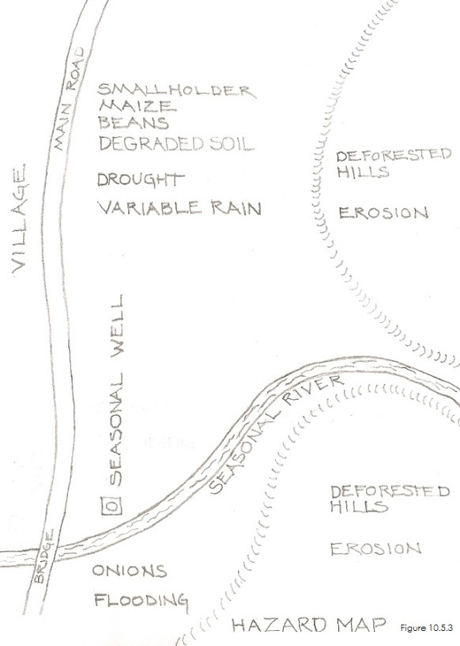

Text Box 2.3
Field Assignment 2.
Activity 3. 1 1/2 hours. Historical timeline

The Historical Timeline is an exercise that is a very simple matrix with years in the left column and important events in the right column. You will be looking for insights into past hazards and events, and how they may have changed or intensified over time.

These could include hurricanes, droughts, health challenges, famines or floods. Hopefully, there will be village elders in the workshop that will allow you to get a long-term perspective from 20 or 25 years ago so that you and the participants can see if these events are occurring more frequently.

Next, when the group has completed the timeline, introduce the subject of climate change. Have they seen a change over time with climate change challenges? When did they start noticing the changes? Some examples:
- beginning 20 years ago rainfall began decreasing; by how much?
- beginning 20 years ago, the growing season changed; it’s shorter now—or it starts later.
- beginning 20 years ago, storms have increased and there is flooding now when there didn’t used to be flooding.
- beginning 20 years ago, we've had to walk progressively further to get water. How much further?

Please note the changes which the participants have seen and briefly describe how they've changed and over what time frame. Does the community realize this is linked to climate change and realize that this may be ongoing?

Note:
- What are the community members’ current coping strategies for dealing with these difficult events?
- Capacity building: Which of the difficult events are they having trouble coping with due to a lack of strategies?

Table 2.3. Course project example: historical timeline
Year | Hazards and Events
2011 | 10 day rainstorm in October drops up to 5 feet of rainwater in parts of Guatemala
2010 | Hurricane Agatha
2009 | Recurring drought in August and September
2008 | Noticeable shift in the beginning and end of the rainy season; unpredictable rainfall
2005 | Hurricane Stan
2004 | Famine in the Polochic region of Guatemala
2001 | Government relocates returning refugees adjacent to the village
2000 | Hurricane Gordon
1996 | End of the Civil War
1995 | Hurricane Mitch
1976 | 7.6 magnitude earthquake

Text Box 2.4
Field Assignment 2.
Activity 4. 1 1/2 hours. Climate hazard impacts on livelihoods

This matrix is another very simple matrix with important livelihood resources and assets in the left column and important hazards in the top row. It's a good idea to prepare the blank matrix on newsprint in advance. Also, take a few minutes alone to list both the hazards and the livelihood assets and resources from the first three activities onto a sheet of notebook paper. These can be used to start a discussion in order to begin filling in the matrix. Doing a quick preliminary matrix on a blank sheet of newsprint during this discussion is also a good idea—you can then just transfer the list of assets and hazards onto a clean, blank matrix.

Typical hazards may include:
- extreme weather events such as hurricanes or cyclones; flooding
- drought/heat waves/cold fronts/heavy snow
- unpredictable beginning and end to the rainy season
- erratic rainfall or more or less rainfall
- change in the timing of the growing season
- health issues/disease
- insect infestations; crop and livestock disease outbreaks

Important assets and resources may include:
- income generation from agriculture
- cooperatives, associations, management committees
- crop land
- crop productivity
- livestock
- irrigation systems
- health
- food reserves/food security
- environmental resources such as forests and water

Once the matrix has been filled in with what the community feels are the greatest hazards along the top row and the most important livelihood assets and resources along the left column, ask them to rank in terms of importance which hazards are having the greatest impact on which resources. There are two ways that you can do this. Much like with the Chapter 1 vote, you could give each participant 15 counting stones, lay the matrix on the floor and let them vote. Or, you can simply hold a discussion and let them rank the importance of hazard impact on resources and mark it on the matrix.
3 = great impact on the resource
2 = median impact on the resource
1 = low impact of the resource
0 = zero impact of the resource

Note:
- What are the community members’ current coping strategies for dealing with these difficult periods?
- Capacity building: Which of the difficult events are they having trouble coping with due to a lack of strategies?

At the end of this exercise you will have a matrix that prioritizes which hazards are causing the greatest risk and are making which livelihood assets and resources the most vulnerable. Discuss this prioritization with the participants for verification—and make sure no one has been left out who has a question or comment.

INSERT TABLE 2.4 NEAR HERE

Table 2.4. Course project example: climate hazard impacts on livelihoods
Shaded area indicates most critical hazard/livelihood impacts prioritized by the community
Livelihood | Change in growing season | Midseason drought | Erratic rain | Extreme tropical storms
Food security and nutrition | 3 | 2 | 3 | 1
Income generation | 3 | 3 | 3 | 2
Crop Productivity | 3 | 3 | 3 | 2
Access to water | 0 | 3 | 3 | 1

Text Box 2.5
Course Project Example
Field Assignment 2. Step 2: Summarizing and Correlating the Results of the Assessment

Climate trends from the PCVA assessment
1. Seasonal calendar
Please prioritize and list the events which occur during the year. Briefly describe how they've changed. Does the community realize that some are linked to climate change and realize that this may be ongoing? Here are results from the Example of Field Assignment 2.

Course Project Example:
The period from May through October appears to be the most critical due to the number of important events and to the fact that it is the rainy season.
Traditional events and challenges:
- planting and harvesting of crops
- rainy season for growing subsistence crops
  - shortage of food for the four months preceding the harvest

Climate change related events:
- unpredictable beginning and end to rainy season
- erratic rainfall during rainy season
- intermittent drought during rainy season
- extreme weather events and flooding

The five month rainy season is very important for the community since it allows them to grow their non-irrigated subsistence crops such as maize and beans. Having an unpredictable start date for the rainy season makes planning for planting difficult. Mid-season drought can impact crop development, and an early end to the rainy season can mean that crops don't reach full maturity. Extreme weather events such as tropical storms and hurricanes can cause flooding, destroy crops, erode topsoil, and damage livelihood assets.

These challenges negatively impact food security and nutrition, levels of crop production, income generation, livelihood assets, and access to water. The workshop participants didn't realize that these negative events may be related to a changing climate.

2. Climate hazard map
Note the hazards which the participants indicated on the hazard map. Briefly describe where the hazards are concentrated and which community members are the most affected. Does the community realize that some are linked to climate change and realize that this may be ongoing? Here are results from the Example of Field Assignment 2.

Course Project Example:
The main hazards that the community voiced during this mapping exercise were:
- flooding of low-lying fields during heavy rain and tropical storms
- drought
- erosion of topsoil and gully formation on steeply sloping fields

These hazards create the greatest challenges for farmers and their farm fields. These challenges reduce crop productivity, impact food security and nutrition for their children, access to water, and family income. The workshop participants didn't realize that these negative events may be related to a changing climate.

3. Historical timeline: Is the community seeing a change in frequency or intensification of hazards and challenges?
Please note the changes which they've seen. Briefly describe how they've changed and over what time frame. Does the community realize that some are linked to climate change and realize that this may be ongoing? Here are results from the Example of Field Assignment 2.

Course Project Example:
This prioritized list of climate related challenges and hazards shows what the participants identified as becoming more frequent or having intensified over the past 25 years:
- change in the timing of the growing (rainy) season; it seems to be starting later and ending earlier
- August traditionally had a two week dry period during the rainy season—the dry period is becoming longer
- erratic rainfall during the rainy season; rainfall has become increasingly erratic
- increase in frequency of tropical storms and extreme weather events (every two to three years); flooding

The increase in the frequency of extreme weather events began 25 years ago in 1995 with hurricane Mitch. Hurricanes and tropical storms happen approximately every two to three years, are quite extreme, and cause damage to crops and farm fields. Although the community is aware that their increased frequency began in recent history, they don't correlate this to a changing climate.

4. A prioritization of climate hazard impacts on livelihoods:
What is a prioritization of the community's greatest hazards they face? What parts of their lives are the most vulnerable? Summarize the hazards and the livelihood assets and outcomes from the Activity 4 as prioritized by the community. Here is the summary from the Example of Field Assignment 2.

Course Project Example:
The greatest hazards that the community voiced during this exercise were prioritized as:
- unpredictable beginning and end to rainy season
- intermittent drought during rainy season
- erratic rainfall during the rainy season
- increase in frequency of tropical storms and extreme weather events (every two to three years); flooding

These climate hazard challenges have a direct and negative impact on these prioritized livelihood assets and resources:
- food security and nutrition
- income generation
- crop productivity
- access to water

Adding information from activities 1 and 2, the most critical time period for these hazards and the livelihood's they impact is the period from May through October. The community members most severely impacted are farmers and their families.

Copyright © 2012, Tim Magee. All rights reserved.

