Agricultural Soil and Water Management for Sloping Land
Tim Magee

Subsistence farmers suffer not only from depleted soils but from challenges with water: too little water, too much water, and erosion from water. This field guide looks at different ways of developing barriers on farm fields for stopping the flow of water so that it can percolate into the soil and build up soil moisture. The barriers also conserve soil by reducing loss from erosion. Organize a three-hour workshop with 12 to 15 farmers from your community.

Barriers to water movement. On sloping farm fields, creating barriers reduces the speed of water movement so that it can be absorbed into the soil rather than simply running off the land. These barriers also catch topsoil that the water carries preventing the loss of this valuable resource and offer the added benefit of creating level planting areas behind the barriers as the soil accumulates. Barriers can be terraces, stone and earth walls called bunds, or living barriers such as hedges and grass strips.

Building terraces and stone retaining walls can be very labor intensive. Less formal constructions such as soil bunds, hedgerows or rows of grass can be less labor-intensive and therefore potentially more attractive to farmers.

One thing that all barriers have in common is that they run horizontally along a level contour across the falling slope of a field. An A-frame leveling device is used to determine the level contour lines which are marked with stakes or with stones.

Here are four techniques for farmers to consider. The technique chosen by each individual farmer will be based upon how steeply a farmer's field slopes, how big their field is, whether they are in a high rainfall or low rainfall region, and how much time they have available for investing in the technique.

Contour ridges. Ridges with furrows on the uphill side are formed approximately 1.5m to 2m apart. This 2m area is the catchment area for rainwater. The ridges are only 15 to 20 cm high—simply high enough to contain the run off—which collects in the furrow. Contour ridges represent the least time investment of these four techniques and can be developed, maintained and improved during preparation for each planting season.

Soil bunds. Soil bunds are a method for both containing water and reducing erosion using on-site materials. After marking the horizontal contour line on the sloping field, a ditch 60 cm deep and 60 cm wide is dug. The soil is placed on the downhill side of the ditch creating the soil wall. The base of the wall is typically twice as wide as the wall is high. Soil bunds are placed from between 5m apart on steep land to 20m apart on more gently sloping land. To determine spacing between the bunds, one rule of thumb is that the top of one bund is level with the base of the adjacent uphill bund. However farmer preferences and the size of the farmer’s field are other determinants.

The soil should be well compacted by hand, then fodder grasses, trees and crops are planted on the bund to stabilize it. Water collects in the ditch during rainstorms and can slowly percolate into the soil increasing soil moisture. As rainwater erodes soil uphill of the bund, the soil will accumulate above the bund and begin creating an increasingly level planting strip. Soil bunds will need annual maintenance—and will need to be checked after heavy rainfall and breaches repaired immediately.

Hedgerows. Hedgerows can also be planted along the contour lines of a hillside—in similar spacing as soil bunds depending on the steepness of the slope of the field. Hedges are usually chosen from nitrogen fixing plants, and from plants that when pruned can be used as fodder for farm animals. Initially, these cuttings can be laid at the base of the hedges on the uphill side to trap eroded topsoil. After two or three years, topsoil will begin to accumulate and form a terrace uphill of the hedgerow. Hedgerows represent substantially less time investment than soil bunds—and use less space—making more land available for planting.

Vetiver grass strips. An inexpensive alternative, vetiver grass can be planted along the contour line of a sloping field to prevent the loss of topsoil, and to reduce the rate at which water runs downhill thereby enhancing infiltration. Topsoil builds up on the uphill side and over time creates level planting areas. Grass strips represent substantially less time investment than soil bunds—and use less space. Grass strips need to be maintained over time to keep them from encroaching into the cropping areas. Grass trimmings can be used as fodder. Vetiver grass is very popular, but check with farmers for local favorites.

Conclusion. Upon completion of this workshop discuss with the farmers which technique would be best suited for them. Then plan a second more specialized training workshop for that specific technique.

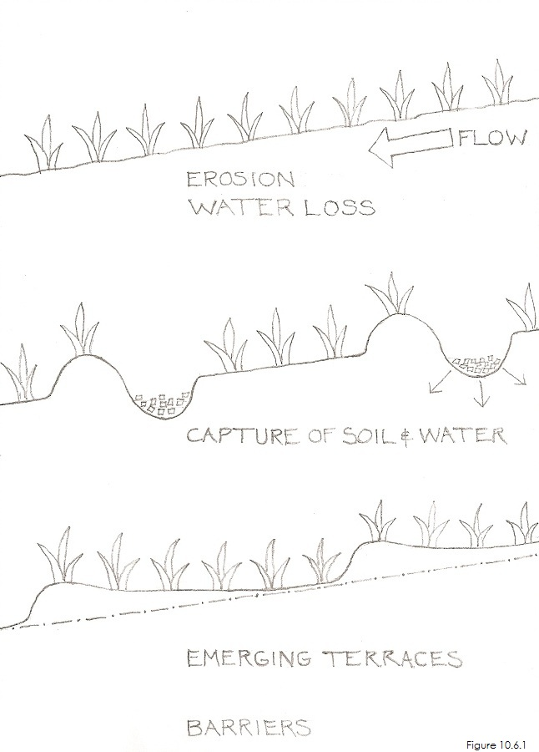 | 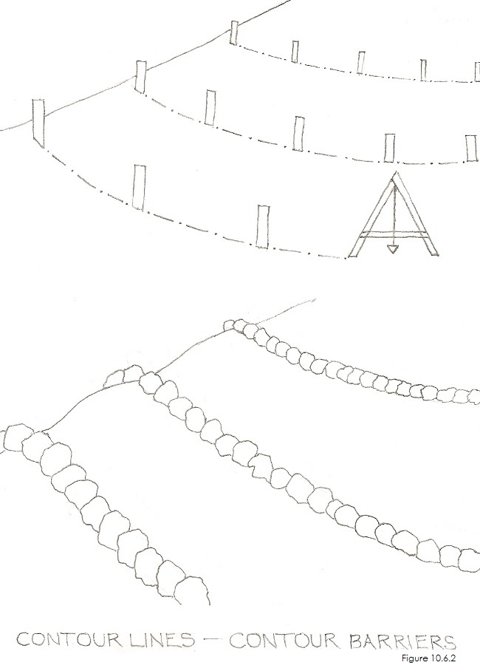
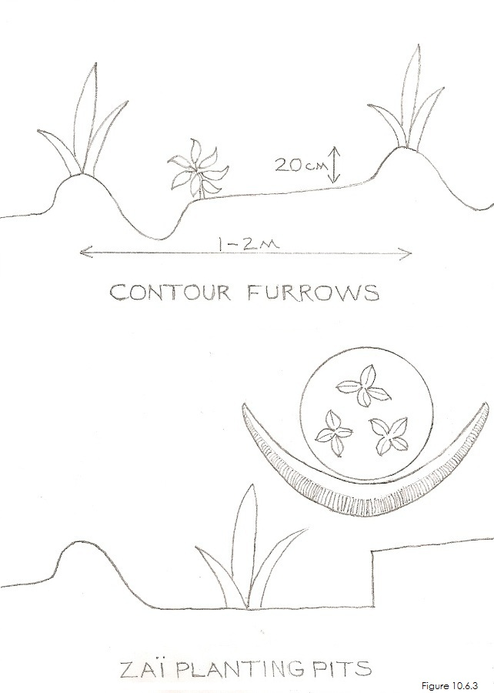 | 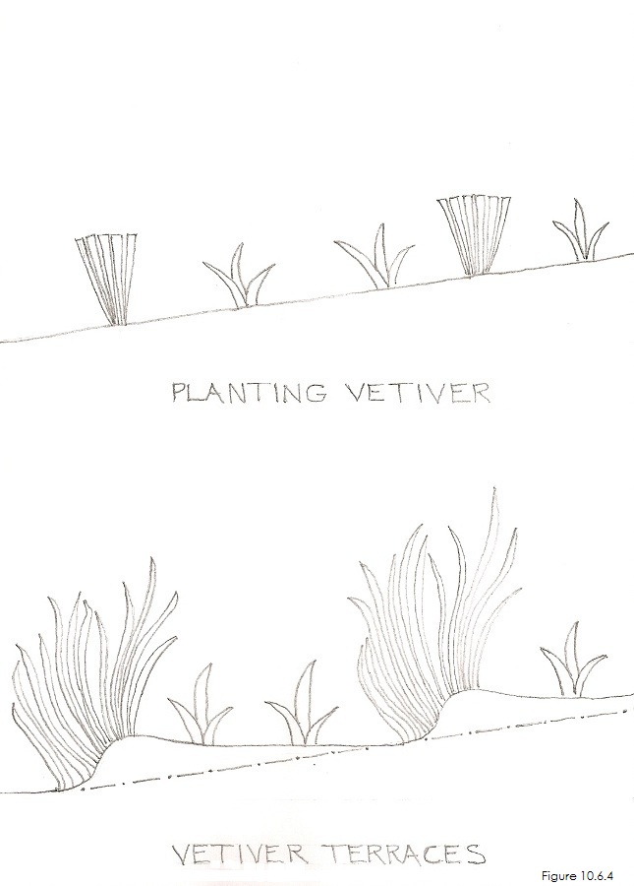
INSERT FIGURES 10.6.1, 10.6.2, 10.6.3, and 10.6.4, NEAR HERE

Workshop Lesson Plan for Agricultural Soil and Water Management for Sloping Land
3 hours

PURPOSE: What workshop participants will be able to do as a result of the lesson.
Support participants in learning about the importance of soil restoration and water conservation.
Objective 1: Participants will understand the importance of keeping rainfall on their fields to replenish soil moisture.
Objective 2: All will know how much topsoil can be eroded from fields and the importance of preventing erosion.
Objective 3: All will learn four simple techniques for barriers on hillsides to prevent the loss of water and topsoil.
Objective 4: Participants will learn how to choose which technique is best for their farm fields.

MATERIALS
- Artist’s drawings/posters; the scenes and people they contain should appear familiar to workshop participants.
- How-To Cards without written words for workshop participants to take home.
- Large sheets of newsprint and tape. Colored markers.

PREPARATION
- Find a workshop location.

BEGINNING OF LESSON:
Activity 1. 40 minutes (including a 15 minute ice-breaker). Soil restoration and conservation introduction
Purpose: Participants will understand the importance of keeping rainfall and topsoil on their farm fields.

What to do
- Ice Breaker: Introductions. Sing a song or play a game.
- Introduction to workshop: Tell the participants what they’ll be able to do as a result of the lesson.
- Discuss the challenges that farmers face due to a shortage of water and soil moisture on their farms.
- Discuss the challenges that farmers face due to a loss of topsoil.
- A practical example of the why farmers need to conserve rainwater and prevent the erosion of their farm’s topsoil is so that their crops can have the moisture and nutrients that they need for productive harvests
- Discuss that there are low-cost barriers that can be built to retain both rainwater and topsoil on their farm fields.

Workshop Participants:
Have participants talk about what they do and don’t understand, what they do and don’t like.

Activity 2. 20 minutes. What are barriers?
Purpose: To understand the importance of barriers in reducing the loss of rainwater and topsoil.

What to do
- Barriers reduce the speed of water movement so that it can be absorbed into the soil rather than running off the land.
- Barriers catch topsoil that the water carries preventing the loss of this valuable resource.
- Barriers create level planting areas behind them as the soil accumulates making sloping fields easier to work in.
- Barriers can be terraces, stone and earth walls called bunds, or living barriers such as hedges and grass strips.

Workshop Participants:
Take 5 minutes to talk about what you do and don’t understand, what you do and don’t like.

Activity 3. 20 minutes. Contour ridges
Purpose: To understand what contour ridges do and where and how to build them.

What to do
- Ridges with furrows on the uphill side are formed approximately 1.5m to 2m apart on gently sloping fields.
- The ridges are only 15 to 20 cm high—simply high enough to contain the run off—which collects in the furrow.
- Contour ridges can be developed, maintained and improved during preparation for each planting season.

Workshop Participants:
Take 5 minutes to talk about what you do and don’t understand, what you do and don’t like.

Activity 4. 20 minutes. Soil bunds
Purpose: To understand what Soil Bunds do and where and how to build them.

What to do
- Soil bunds are a method for both containing water and reducing erosion using on-site materials.
- After marking the horizontal contour line on the sloping field, a ditch 60 cm deep and 60 cm wide is dug.
- The soil is placed on the downhill side of the ditch creating the wall.
- Soil bunds are placed from between 5m apart on steep land to 20m apart on more gently sloping land.
- Soil bunds should be well compacted by hand.
- Fodder grasses, trees and crops are planted on the bund to stabilize it.
- Water collects in the ditch during rainstorms and can slowly percolate into the soil increasing soil moisture.
- Soil will accumulate above the bund and begin creating an increasingly level planting strip.

BREAK: 15 minutes

Activity 6. 20 minutes. Hedgerows
Purpose: To understand what hedgerows do and where and how to plant them

What to do
- Hedgerows can also be planted along the contour lines of a hillside—in similar spacing as soil bunds.
- Hedges are usually chosen from nitrogen fixing plants, and from plants that can be used as fodder for farm animals.
- After two or three years topsoil will begin to accumulate and form a terrace uphill of the hedgerow.
- Hedgerows represent a smaller time investment than soil bunds—and use less space making more land available for planting.

Workshop Participants:
Have participants talk about what they do and don’t understand, what they do and don’t like.

Activity 7. 20 minutes. Vetiver grass strips
Purpose: To understand what vetiver grass strips do and where and how to plant them

What to do
- An inexpensive alternative, vetiver grass is planted along the contour line of a sloping field to prevent the loss of topsoil.
- Vetiver grass strips reduce the rate at which water runs downhill enhancing infiltration.
- Topsoil builds up on the uphill side and over time creates level planting areas.
- Grass strips represent substantially less time investment than soil bunds—and use less space.
- Grass strips need to be maintained over time to keep them from encroaching into the cropping areas.
- Vetiver grass is very popular, but check with farmers for local favorites.

Activity 8. 30 minutes. Conclusion
Purpose: To reinforce what has been learned and to discuss positive solutions.

What to do
- Discuss and review what has been learned.
- Reinforce the principles of soil restoration and conservation
- Barriers reduce the speed of water movement so that it can be absorbed into the soil.
- Barriers also catch topsoil that the water carries preventing the loss of this valuable topsoil.
- Barriers create level planting areas behind the barriers as the soil accumulates.
- Barriers can be terraces, stone or earth walls called bunds, or living barriers such as hedges and grass strips.

- A farmer’s choice of barriers will depend on how steep their field is, how big their field is, level of rain and their available time.
- Discuss with the farmers what will be the most appropriate barrier for them to build on their farms.
- Arrange the next workshop with the farmers to begin the training process for building the barriers that they've chosen.

Workshop Participant Feed Back:
Have participants talk about what they do and don’t understand, what they do and don’t like.

